Drink & Eat Oregon 2018

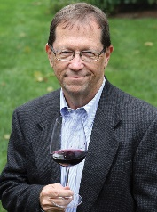
Join wine journalist Howard Hewitt for four days and five nights to Drink & Eat Oregon. We’ll start and finish in Portland with four days of fun in the Willamette Valley. You pay one price and everything from your Tuesday night hotel in Portland to your Saturday night Portland hotel is included.
Transportation to and from Portland is not included.
Tuesday, Oct. 9
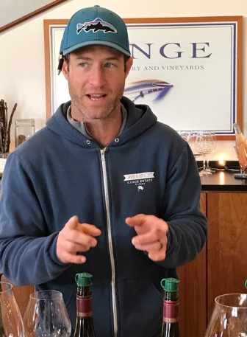
Arrive at downtown hotel. Room reserved in your name
9 p.m. – “Welcome to Oregon” Reception at Hotel
Wednesday, Oct. 10
Depart hotel by van for the Willamette Valley
Lunch and tasting at a Dundee Hills Winery
Afternoon – More tasting!
4-5 p.m. – Check in to the beautiful Youngsberg Hill Inn.
Evening – Dinner in McMinnville
Thursday, Oct. 11
A full day of tasting: We’ll visit three wineries
Light lunch, probably at one of the wineries
Return to Inn
Dinner in McMinnville or Newberg
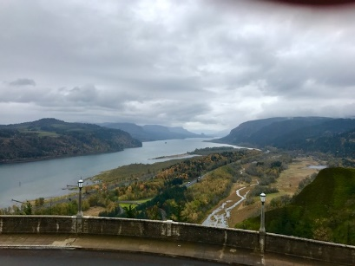
Friday, Oct. 12
One of the highlights of the trip – A drive to see the stunning Columbia River Gorge and Multnomah Falls, with lunch in Hood River. Depending on time of day and weather, we may return through Mt. Hood National Park for stunning views of the snow-capped mountain.
7 p.m. – Dinner at the Inn

Saturday, Oct. 13
2-3 winery visits and a stop at the fabulous Republic of Jam!
Return to Portland
Downtown Portland Hotel Stay
Dinner at one of the best pubs celebrating Portland beer culture
Sunday, Oct. 14 – Departure
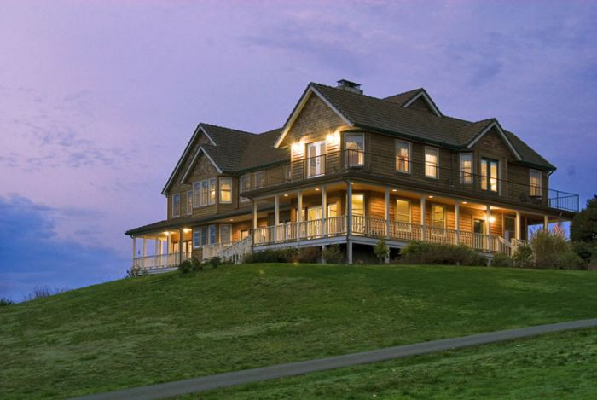
What’s covered?
All lodging for this trip is included – Two nights stay in downtown Portland and three nights in the Willamette Valley at the Youngsberg Hill Inn (at right). All meals are included. Breakfast will be at the Inn each morning at Youngberg. We’ve learned from previous trips that we had too much food during the day – is there such a thing? But we’re going to take it light at lunch, largely charcuterie type spread while each night will be at some of the best restaurants in the valley.
All tasting fees are included. Most of our winery visits will be with the winemaker or owner. All ground transportation Wednesday morning through return to Portland is included. We have a private licensed driver and appropriate-size van. A special perk to Howard’s trips – you’ll be provided a box for a case of wine. You simply fill it up with your winery purchases and we’ll see it gets shipped directly to your home. That cost is included. Buying the wines – up to you
But what wineries?
The wineries we’re most likely to visit include: Lange, Winderlea, Alloro, Drouhin, Vidon, Lenne, Ken Wright, Ghost Hill, Alexana, Bergstrom, Youngberg Hill, and Adelsheim. We will visit 7-8 wineries and try to sample other wines at our dinners. The above list is a sample – some will be included.
What about the restaurants?
Newberg’s Recipe Part Deux (leading farm to fork restaurant in the valley), Nick’s Italian Café in McMinnville (not just pasta, this will be special!), Tina’s in Dundee (one of the oldest fine dining spots in the valley.) And, after our day in the van seeing the Gorge, we’ll return to the inn for an evening of relaxation and dinner prepared just for us by an area chef.
Costs?
The cost is $2460 per person, double occupancy. (Actually less than my 2014 group trip) I take care of every detail for you once you arrive until you leave. I am your tour guide and concierge. I encourage regular travelers to check a 5-night, 4-day wine visit and compare costs. I must have four couples (or 8 people to run this trip.
Payment and deadlines
$500 deposit, per person due by July 15. Balance will be due Aug. 1
Cancellations prior to Aug 1, deposit returned. Cancellation after Aug 1 results in forfeiture of deposit, balance returned. If trip is not full sold, your full deposit will be returned.

At this time I do not have capability to accept electronic payment of any type. Make Checks payable to Howard W. Hewitt, Grape Sense. Mail check to: Howard Hewitt, 1119 Sterling St., Apt. 3, Indianapolis, 46201
A registration form will sent upon receipt of deposit.

